8. ReactJS-HOL:
Create a react app with the name “counterapp” & open it in the vs code.
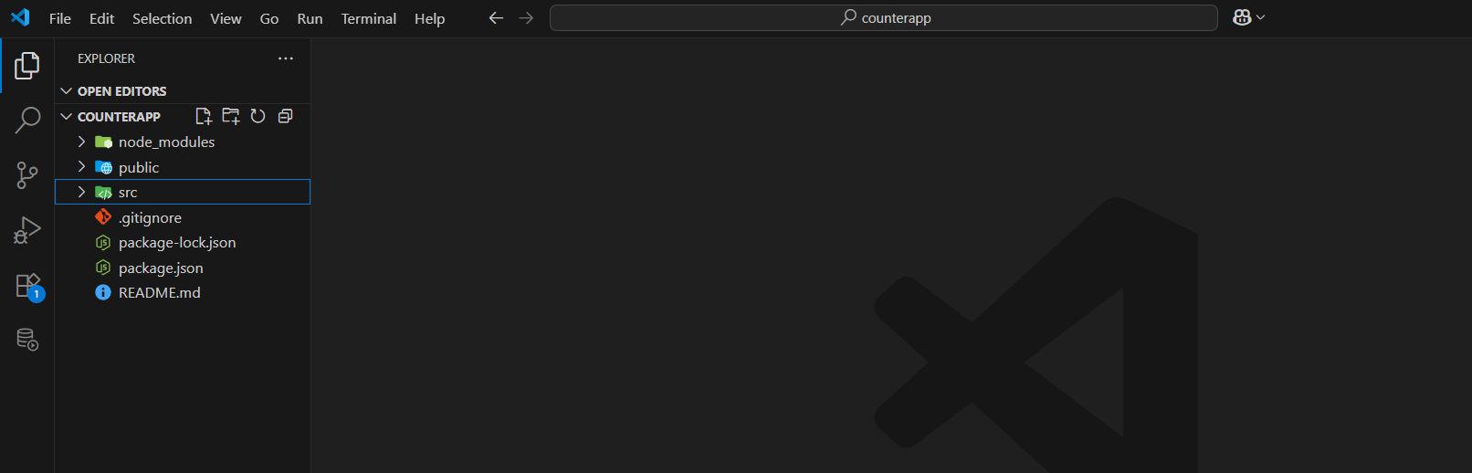
Create a CountPeople component
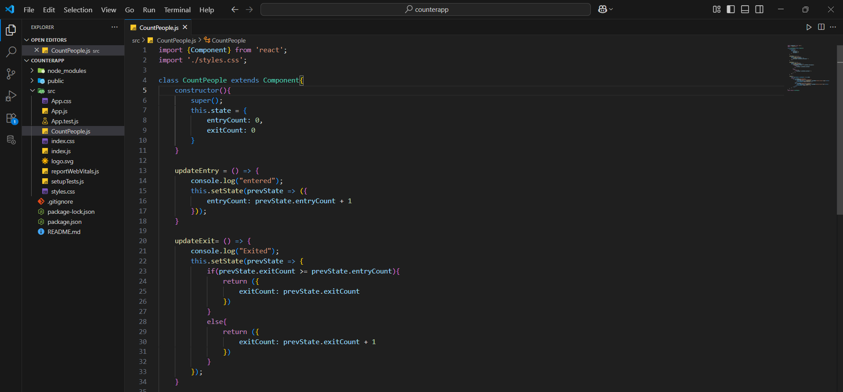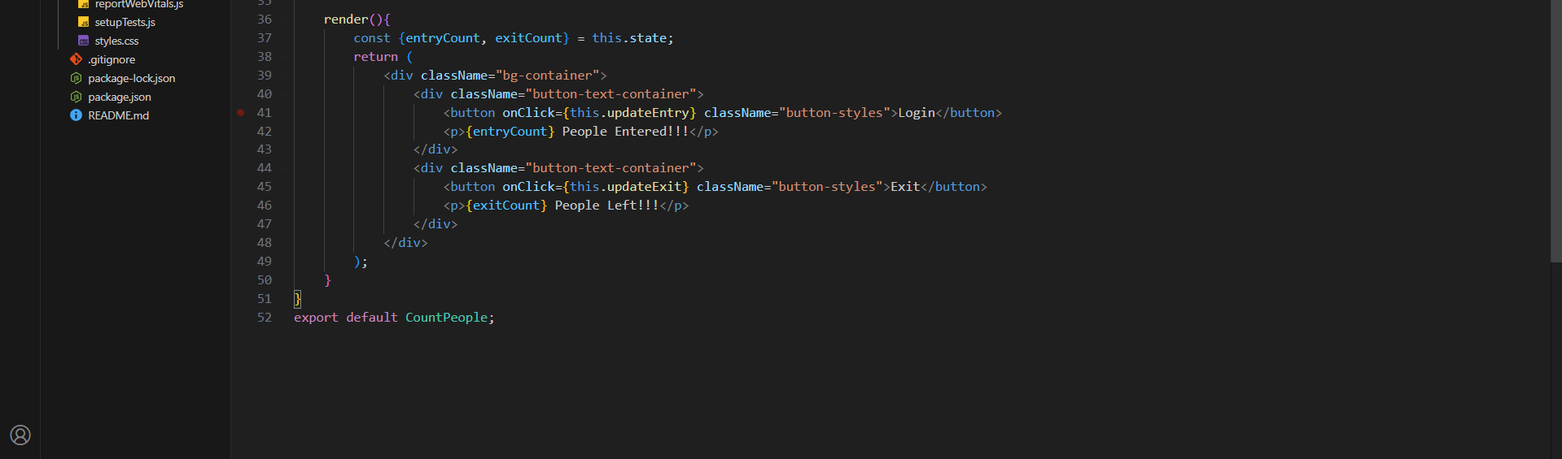
App component:
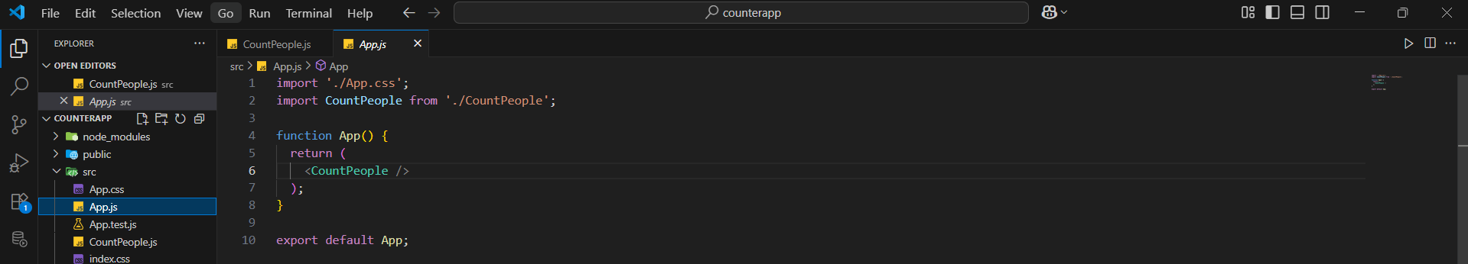
Styles.css:
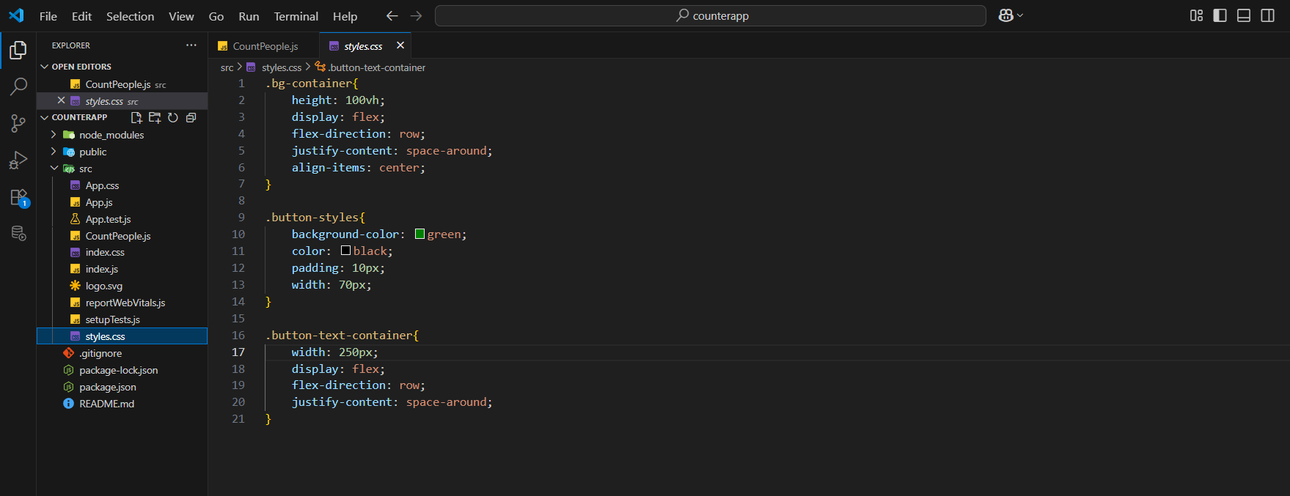

Output:
